Big Data Course Term Project
Recommendation System - Amazon Books
Ashwini Kulkarni, Sindhu Balakrishnan

Computer Science Department, Indiana Universtiy-Purdue University
Fort Wayne, IN, 46805,
{ kulka02, balas01}@students.ipfw.edu
Abstract. Purpose of this project is to build a recommendation system which would suggest the user with products which has a likelihood that he/she might prefer to buy. This terminology is similar to suggested products section in Amazon website. The dataset we are using is an archive from Amazon product review. The goal of the project is to implement a data analysis strategy/process to recommend users with Top 10 books he would likely buy. The resultant set should be filtering out the books he/she has already purchased from the website.
Keywords: BigData, Recommendation System, JavaRDD, Spark, Spark SQL
1 Introduction
To suggest Users with a list of Top 10 books, we need to know historical order information for that particular user to retrieve the list of books he/she already bought. Depending on this, we will have to find a correlation with other users who has the same books in their historical order list. We will then have to implement an algorithm to get top 10 list of maximum sold books from correlated book data set, however we should be removing the list of books the input user has already purchased.
This idea is similar to suggested products section in Amazon website except we are not suggesting books which the user has already bought. (Fig. 1.1)

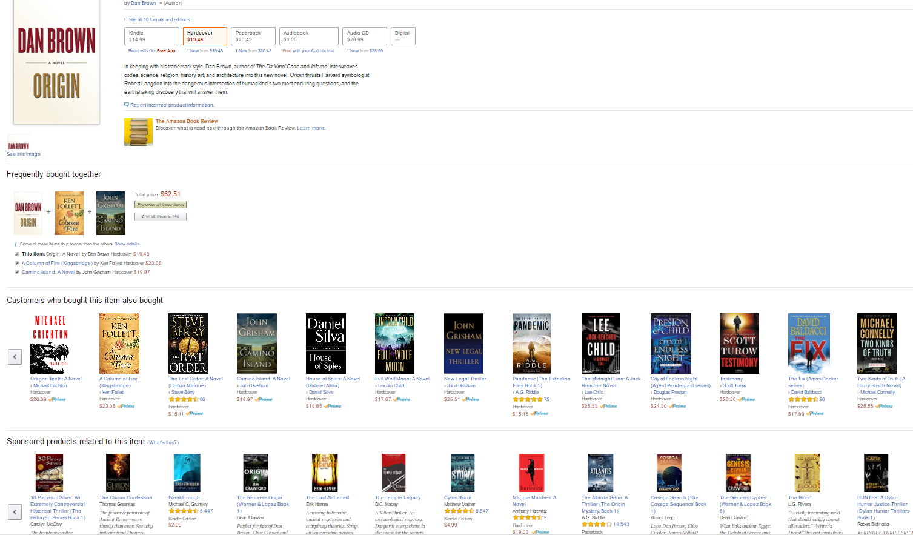
Fig. 1.1

  - The project problem description
The implementation expected in this work is to return a Top selection of books that a user might show interest to buy from the website. To maximize the likehood of purchase the Top selection returned should match the user’s preference/ interest. It should also not return an item that already exists in his past order history, though it comes under his/ her preference/ interest.
  - Motivation of your problem
Have been amused by the way the recommendations are suggested in amazon or any big website for that manner. However, from a user experience perspective, returning a recommendation that already was brought by the user in that past is not a good idea, unless the user prefers to buy multiple copies of the same item, which is a not a common scenario.
  - Applications (areas)
This approach can be extended to almost any online retail portal, movie/ restaurant recommendations etc. Implementing this work in movie recommendation systems like Netflix, would be very beneficial for users, who not like to view a recommendation for an already watch movie. Which would ultimately make the user experience much better rather than skipping a whole bunch of already watched movies.
  - Goal and objectives
The objective of this implementation is to build a recommendation system which would suggest the user with products which has a high likelihood that he/she might prefer to buy. The likelihood is calculated based on tastes/interests of similar users.
  - Challenges (e.g., hardness to solve the problem)
The implementation method by itself is simple, but spanning through the high volume of original dataset of size 142.8 million is highly sophisticated. Also, the input format is in json, decoding and extracting the values from that format is feasible, however implementing this algorithm on these values is computationally very expensive.

  - A short description of your approach (a short paragraph)
In a user-based approach, identify a list of similar users who exhibit common patterns in their order history in some way or the other. Then it will be assumed that the input user has preferences that match the similar user category. Based on this, recommendations extracted from the similar user categories are suggested for the input user.

  - A short description of your result (2-3 sentences)
The result will include only the Top book suggestions from the similar user categories after some basic computations like maximum sold books. It also includes filtering out user’s past purchase history.

- Related Work
- Big Data Correlation Concepts
- Automatic Suggestion in Products section in Amazon Retail website/application.
- Methodology
  - General Methods in Recommendation Systems

- Content-based filtering:
Recommending items similar to what users already like.

- Collaborative filtering:
Recommending items based on what similar users like. Collaborative filtering approach is opted for this project.

  - Collaborative filtering

If two users have exhibited similar preferences (that is, patterns of interacting with the same items in broadly the same way), then we would assume that they are similar to each other in terms of taste. To generate recommendations for unknown items for a given user, we can use the known preferences of other users that exhibit similar behavior.
We can do this by selecting a set of similar users and computing some form of combined score based on the items they have shown a preference for.
The overall logic is that if others have tastes similar to a set of items, these items would tend to be good candidates for recommendation.
4. Technology
Platform: Windows

Processing Paradigm: Spark, SparkSql

Programing language: JAVA

Other: Maven
5. Approach
For particular user id X we have to find top 10 recommendations with following steps:-

- Program finds the past list of books bought by the user – RDD1
- Program searches the whole dataset and returns users who have bought books in RDD1 –&gt; RRD2
- Find all the books bought by those users in RRD2 except books in RDD1– &gt;RDD3
- For each book in RDD3 find maximum sold books – List
- Recommend the top 10 books from list as RDD4

A new Spark RDD created at each step and performs the conditional check. The list returned by the RDD is set to a Broadcast Variable. Maximum sold books are sorted are top 10 records returns the suggestion to user.
- Results
  - Data
- We have downloaded dataset from Amazon share point:
http://jmcauley.ucsd.edu/data/amazon/
Dataset is basically historical Amazon books review from website.
- This dataset contains book reviews from Amazon, including 142.8 million reviews spanning May 1996 - July 2014. This dataset includes reviews (ratings, text, helpfulness votes).
- We are mainly focusing on following two features in our implementation.
Data attributes:-
Feature ID | Description
User ID | Contains reviewer ID
Product ID | Unique ID for Each Product
Table 6.1

  - Dataset Format: (refer fig 6.2)

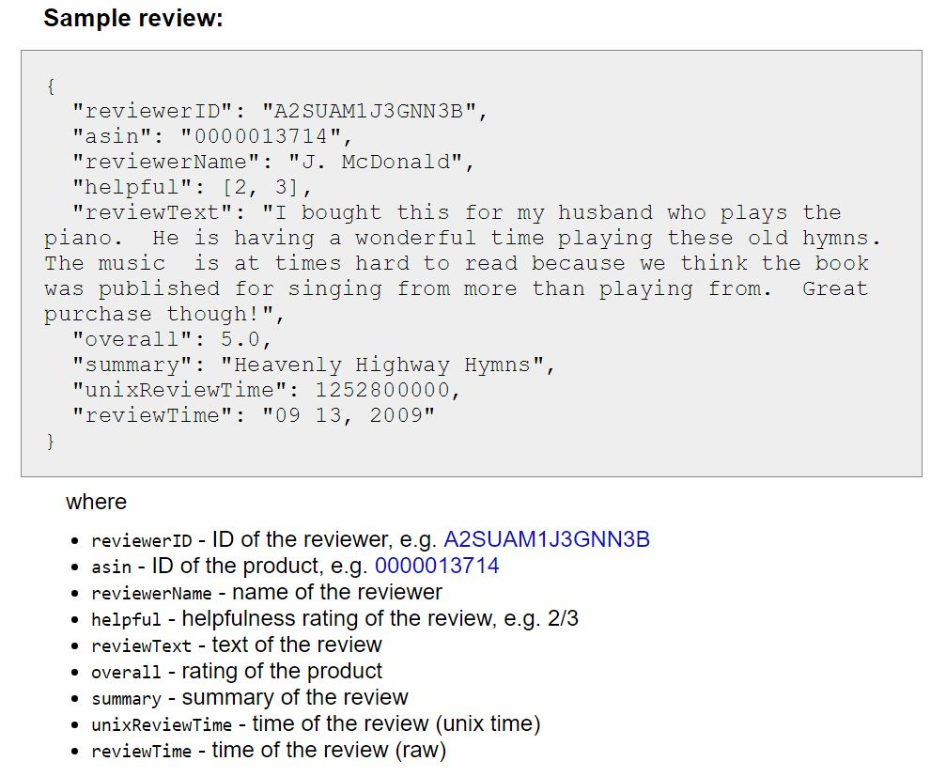
fig 6.2

  - Data Pre-Processing

Loading JSON to a comma separated file for RDD Implementation.
By Using JavaRDD of Required schema type and then loading into SparkSQL Temporary database, and create file with comma separated format as follows (fig. 6.3)

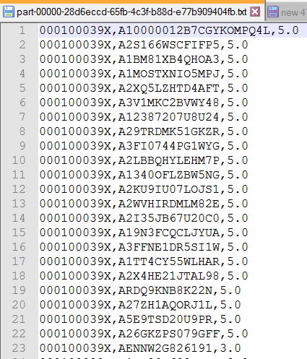
fig. 6.3

  - Result

Expected Output:
On specifying a user id as input, it should return top book suggestions after spanning through 142.8 million book reviews within a reasonable period of time.

Actual Output: (refer fig. 6.4)
Description:
RDD1:- List of Books bought by input user X.
RDD2:- List of Users bought books present in RDD1.
RDD3:- List of Books bought by users present in RDD2 except books in RDD1.
RDD4:- Count of each Book in RDD3 bought by all users stored in list and after sorting list, selecting top 10 books from list.

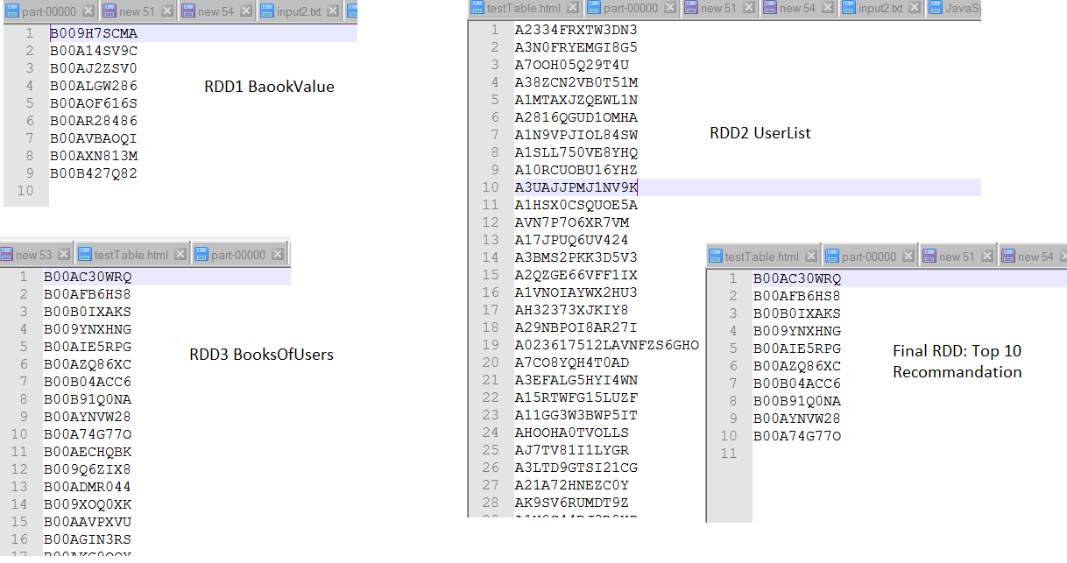
Fig. 6.4
- Conclusion
7.1 Summary
Project Statement: Suggest user with top book recommendations.
Result: Top 10 Book suggestion for the user based on his past preferences.

7.2 Limitations and future work
Currently, implementation is based on users past history. Future work can include suggestions for new users too.

- Try a hybrid approach:

- Cascade (Content + Collaborative Filtering).
- After content based filtering, collaborative filtering can be applied to refine the recommendations even more.
- Integrating (Content + Collaborative Filtering + K-Means).
- Recommendations by more than 1 algorithm could be more accurate.

- Implementation using Real Time data.
- Expand applications for other attributes.
- Minimizing large file processing time.
References
- http://jmcauley.ucsd.edu/data/amazon/
- https://www.packtpub.com/books/content/building-recommendation-engine-spark
- https://bugra.github.io/work/notes/2014-04-19/alternating-least-squares-method-for-collaborative-filtering/
- https://www.slideshare.net/CasertaConcepts/analytics-week-recommendations-on-spark
Appendix:
RDD: Resilient Distributed Datasets
SparkSql: Spark SQL is a Spark module for structured data processing.
JSON: (JavaScript Object Notation) is a lightweight data-interchange format. It is easy for humans to read and write. It is easy for machines to parse and generate.

***

